**Experiment: 07**

**Date: 27.04.2022**

**Title: Assignment Problem Solution with Excel Solver.**

**Question:**

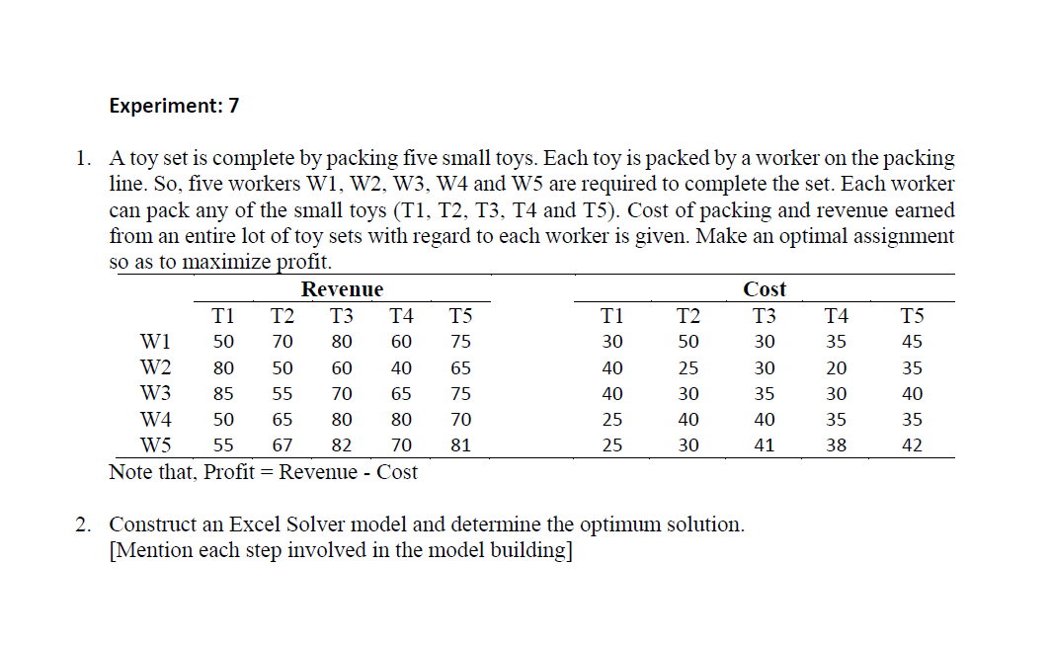

**Answer:**

1. **Formulate the associated Assignment Problem:**

**Here,**

**Profit = Revenue - Cost**

**The Profit Matrix is:**

|  |  |  |  |  |  |  |
| --- | --- | --- | --- | --- | --- | --- |
| **To**  **From** | **Profit** | | | | | **Supply** |
| **T1** | **T2** | **T3** | **T4** | **T5** |
| **W1** | **20** | **20** | **50** | **25** | **30** | **1** |
| **W2** | **40** | **25** | **30** | **20** | **30** | **1** |
| **W3** | **45** | **25** | **35** | **35** | **35** | **1** |
| **W4** | **25** | **25** | **40** | **45** | **35** | **1** |
| **W5** | **30** | **37** | **41** | **32** | **39** | **1** |
| **Demand** | **1** | **1** | **1** | **1** | **1** |  |

**Mathematical Model of an Assignment Problem :**

**Let,**

$$x_{ij}=\left\{\begin{aligned} 0 , if i-th worker is not assigned to packed j-th toy \\ \\ 1, if i-th worker is assigned to packed j-th toy\end{aligned}\right.$$

$C_{ij}=The profit to complete packing by i-th worker to the j- th toy$

$$a_{i}=1 , i=1,2,3,….…...…..,n$$

$$b_{j}=1 , j=1,2,3,………..…..,n$$

**[As, One worker can be assignment to pack one toy only ]**

**Then the mathematical model for an Assignment Problem is given by find $x_{ij}$ so as to –**

$$Maximize Z =\sum_{i=1}^{n}{\sum_{j=1}^{n}{C_{ij}x_{ij}}}$$

**Subject To,**

$$\sum_{j=1}^{n}{x_{ij}}=1 , i=1,2,3,…………….,n (Supply Constraint)$$

$$\sum_{i=1}^{n}{x_{ij}}=1 , j=1,2,3,…………….,n (Demand Constraint)$$

$$x_{ij }∊\left\{ 0 , 1\right\} , ∀ i , j$$

**2. Assignment Problem Solution with Excel Solver:**

**In Excel Solver, the spreadsheet is the input and output medium for the Assignment problem. We use the following steps to formulate the following model in Excel:**

**Assignment model:**

|  |  |  |  |  |  |  |
| --- | --- | --- | --- | --- | --- | --- |
| **To**  **From** | **Profit** | | | | | **Supply** |
| **T1** | **T2** | **T3** | **T4** | **T5** |
| **W1** | **20** | **20** | **50** | **25** | **30** | **1** |
| **W2** | **40** | **25** | **30** | **20** | **30** | **1** |
| **W3** | **45** | **25** | **35** | **35** | **35** | **1** |
| **W4** | **25** | **25** | **40** | **45** | **35** | **1** |
| **W5** | **30** | **37** | **41** | **32** | **39** | **1** |
| **Demand** | **1** | **1** | **1** | **1** | **1** |  |

**Step 1:**

* In the first step, create the Assignment table in an Excel spreadsheet. The table should contain origins, destinations, cost per unit from each supply center to demand center, the supply capacity at each origin, and the demand of each center. This is shown in the Excel matrix indicated by cells **I3:P10**.

**Step 2:**

* Check whether the problem is balanced or not by comparing the total supply and the total demand. If total demand is more than the total supply then add a dummy origin (i.e., a row in the cost matrix) with the cost values as zero. Similarly, if the total supply is more than the total demand then add a dummy destination (i.e., a column in the cost matrix) with the cost values as zero.

**Step 3:**

* At the bottom of this Assignment matrix, a linear model is constructed with decision variables (**Cell: J15:N19**), objective function (**Cell: J23**) and both supply and demand constraints (**Cell: P15:P19** and **J21:N21**, resp.). This is shown in cells **I14:P23**.

**Step 4:**

* Objective function is to maximization the total Profit. A formula for computing the objective function value is created in a cell. Cell **J23** would give the final value of maximize profit.

For its calculation, a formula has to be created one can use **SUMPRODUCT** function available in the excel spreadsheet as the following :

**Cell J23:** **=SUMPRODUCT(J15:N19,J4:N8)**

**Step 5:**

* Formula for computing the **total supply** from different origins are formulated in **Cell** **P15:P19**.

The formulas are as follows:

**Cell P15:=SUM(J15:N15),**

**Cell P16:=SUM(J16:N16),**

**Cell P17:=SUM(J17:N17),**

**Cell P18:=SUM(J18:N18),**

**Cell P19:=SUM(J19:N19)**

**Step 6:**

* Formula for computing the **total inflow** at different destinations are formulated in **Cell** **J21:N21**.

The formulas are as follows:

**Cell J21:=SUM(J15:J19),**

**Cell K21:=SUM(K15:K19),**

**Cell L21:=SUM(L15:L19),**

**Cell M21:=SUM(M15:M19),**

**Cell N21:=SUM(N15:N19)**

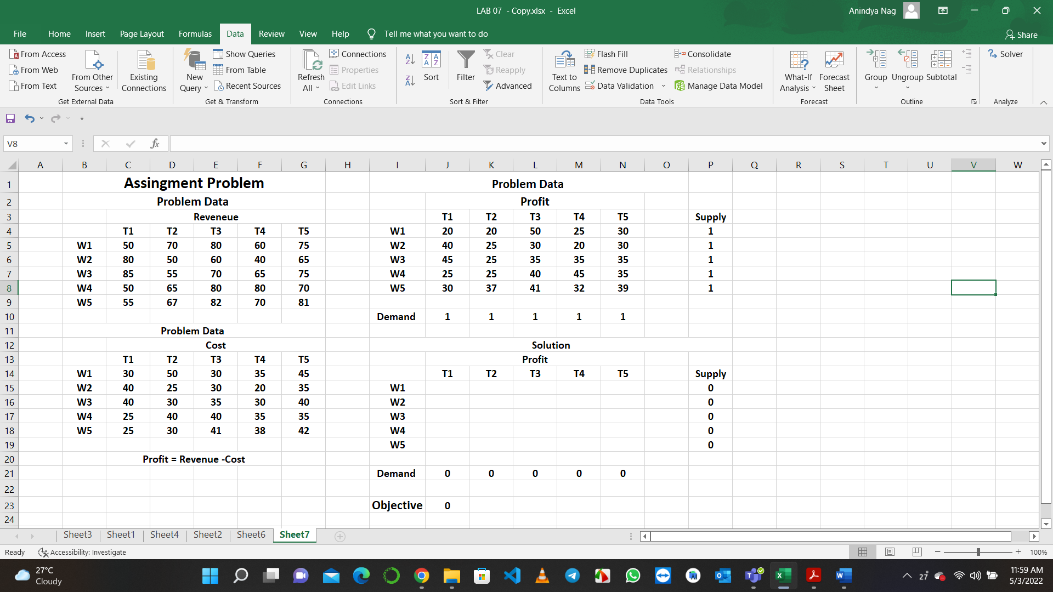

**In Microsoft Excel, after entering the entire Assignment Problem data in the worksheet, the following steps would lead to a solution:**

**Step 1:**

* Select **Data** menu in the toolbar.

**Step 2:**

* In Data menu, select **Solver** application.

**Step 3:**

* Open Solver application. In Solver parameters dialog box Enter **$J$23** in set target cell. Select purpose of **max** (depending on the type of the objective). Enter **$J$15:$N$19** in by changing cell box. To enter constraint equations, click on **Add** button.

**Step 4:**

* When the **Add** constraint dialog box opens, it would have three boxes: first, cell reference; second, inequalities of **≤** and lastly, constraint box. For supply constraints, enter **$P$15:$P$19** in cell reference box; enter inequality of **=** and **$P$4:$P$8** in the constraint box. Then click on Add to add demand constraints in the similar process. After entering all constraints, click **OK**.

**Step 5:**

* Now choose Options. Select Assume Non-Negative and Assume Linear Model (in **MS Excel 2007**). In **Excel 2010** onwards, select Make Unconstraint Variables Non-negative and select Simplex LP from the dropdown menu of Select a Solving Method. Click **OK**.

**Step 6:**

* When Solver parameters dialog box appear, click on **Solve**.

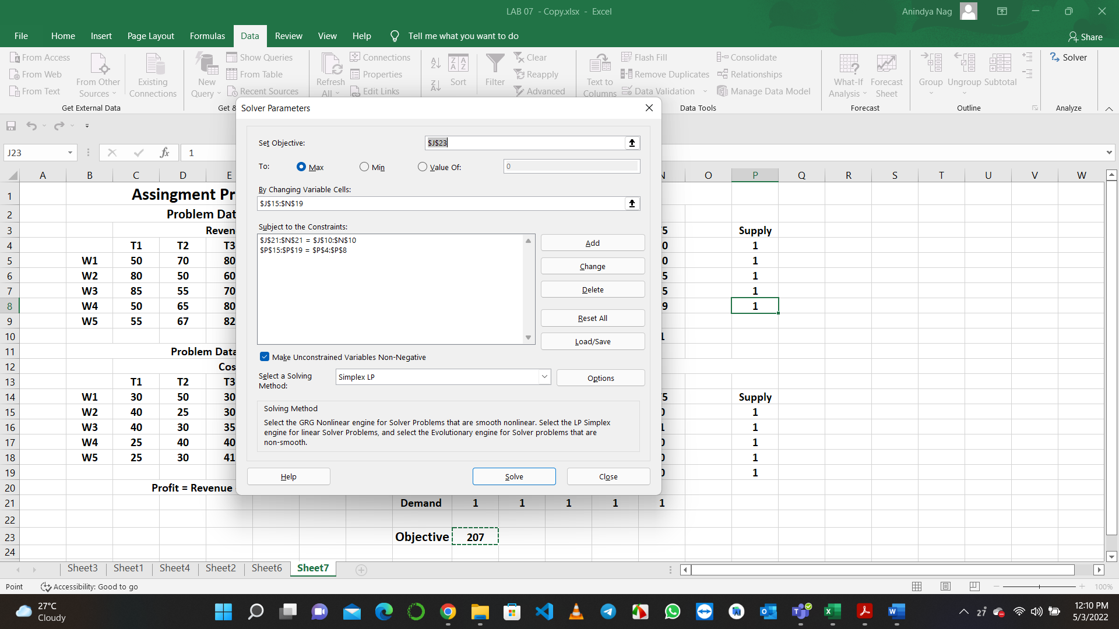

**Step 7.:**

* Finally, when final solution appears on the worksheet, select Keep Solver Solution and click **OK**.

**Output:**

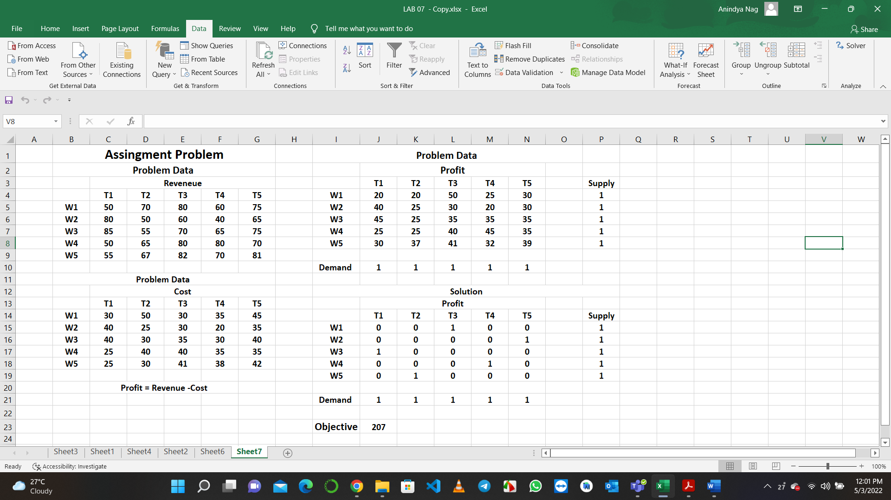

**Conclusion:**

**The obtained optimal assignment of the assignment problem with the maximum profit is given by:**

$$W_{1} → { T}_{3}$$

$$W_{2} → T_{5}$$

$$W_{3 }→ T_{1}$$

$$W_{4} → { T}_{4}$$

$$W_{5} → T_{2}$$

**Maximum Profit $=50+30+45+45+37=207$**